RESUME

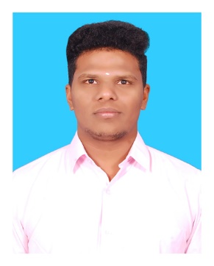

NAME : Dillibabu E P

E-MAIL : [dillibabu11052000@gmail.com](mailto:dillibabu11052000@gmail.com) MOBILE : +91- 8438523888

# OBJECTIVE:

## Seeking a challenging opportunity which will help me to explore myself fully and realize my potential and where I can utilize my knowledge appropriately and for the welfare and growth of the organization I work for. Willing to work as a key player in challenging & creative environment.

# ACADAMIC CREDENTIAL:

|  |  |  |  |  |
| --- | --- | --- | --- | --- |
| **Course** | **School/College** | **Board/University** | **Year of Passing** | **Percentage/CGPA** |
| B.E  (Mechanical) | PERI Institute of Technology | Anna University | 2022 | 7.00(till 5th semester) |
| H.S.C | Government Boys Higher Secondary  School, Podattur pet. | State Board | 2018 | 68.0 |
| S.S.L.C | Government Boys Higher Secondary School, Podattur pet. | State Board | 2016 | 87.6 |

## TECHINICAL SKILLS:

* CATIA Software
* Welding and Drilling
* Microsoft Office
* Lathe Machining

# PROJECT:

## Mini-Project:

Title: Design and Fabrication of Multi Nozzel Wheel Spray Pump

## Final - Project :

Title: Design and Analysis of Disc Brake Rotor. (Process going on)

# AREA OF INTEREST:

* Designing
* Lathe Machine works

# CO-CURRICULAR ACTIVITIES:

* Having experience of visiting industrial visit at ASHOKE LEYLAND.
* Awarded for Securing full attendance during school level.
* Participated in various inter department Cultural Events during college level.

**INTERPERSONAL SKILLS:**

* Ability to cope up with different situations.
* Able to lead a team.
* Positive thinking and motivated.
* High Grasping power.

## DECLARATION:

I hereby declare that the above given information is true to best of my knowledge and ability.

PLACE : PODATUR PET Yours Faithfully,

DATE : ( Dillibabu E P )